Q1. Load the "titanic" dataset using the load_dataset function of seaborn. Use Plotly express to plot a scatter plot for age and fare columns in the titanic dataset.

import seaborn as sns

titanic = sns.load_dataset('titanic')

titanic.head()

import plotly.graph_objects as go

fig = go.Figure()  # to create a figure

fig.add_trace(go.Scatter(x = titanic.age , y = titanic.fare , mode = 'markers'))    # to create a Scatter plot

fig.show()

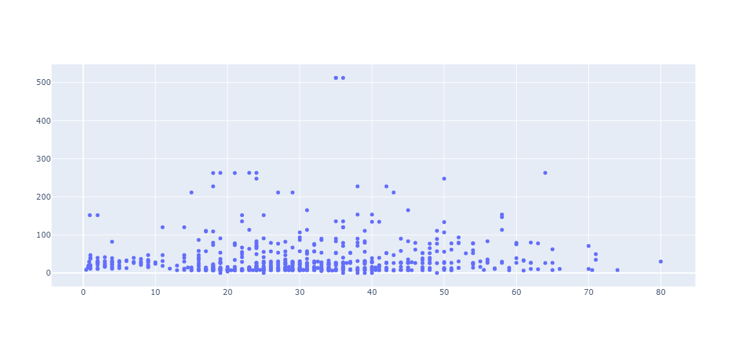

# Q2. Using the tips dataset in the Plotly library, plot a box plot using Plotly express.

# Answer :

# Importing tips dataset from plotly express

import plotly.express as px

tips = px.data.tips()

tips.head()

# Plotting Boxplot

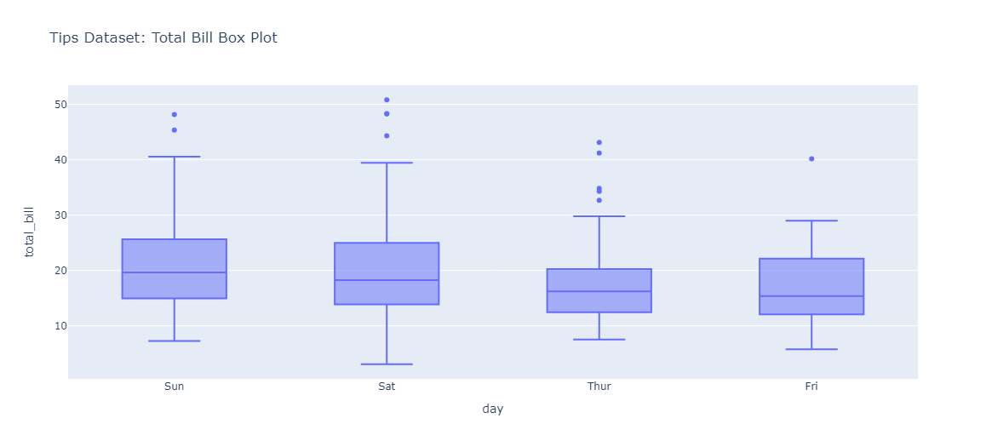

# Q3. Using the tips dataset in the Plotly library, Plot a histogram for x= "sex" and y="total_bill" column in the tips dataset. Also, use the "smoker" column with the pattern_shape parameter and the "day" column with the color parameter.

# ANS:-

# Plot a histogram for "sex" and "total_bill" columns using Plotlyexpress

fig = px.histogram(tips , x= "sex" , y="total_bill" , pattern_shape = "smoker" , color = 'day' , title="Tips Dataset: Total Bill by Gender and Smoking Status")

fig.show()

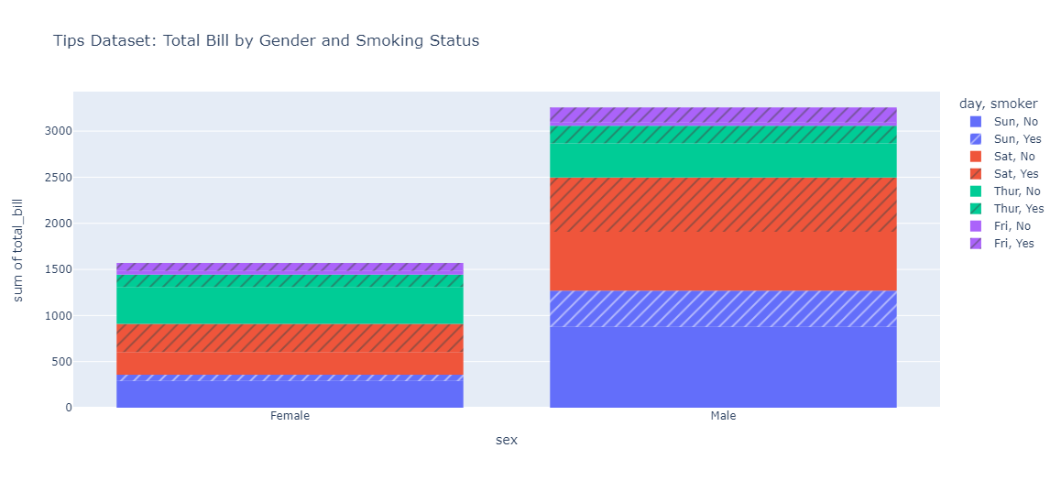

# Q4. Using the iris dataset in the Plotly library, Plot a scatter matrix plot, using the "species" column for the color parameter.

# Note: Use "sepal_length", "sepal_width", "petal_length", "petal_width" columns only with the dimensions parameter.

import plotly.express as px

# Load the "iris" dataset from Plotly

iris = px.data.iris()

iris.head()

# Plot a scatter matrix plot using Plotly express

fig = px.scatter_matrix(iris , dimensions = ["sepal_length", "sepal_width", "petal_length", "petal_width"],

                        color = "species" , title="Iris Dataset: Scatter Matrix Plot")

# Updating the height of figure

fig.update_layout(height=800)

fig.show()

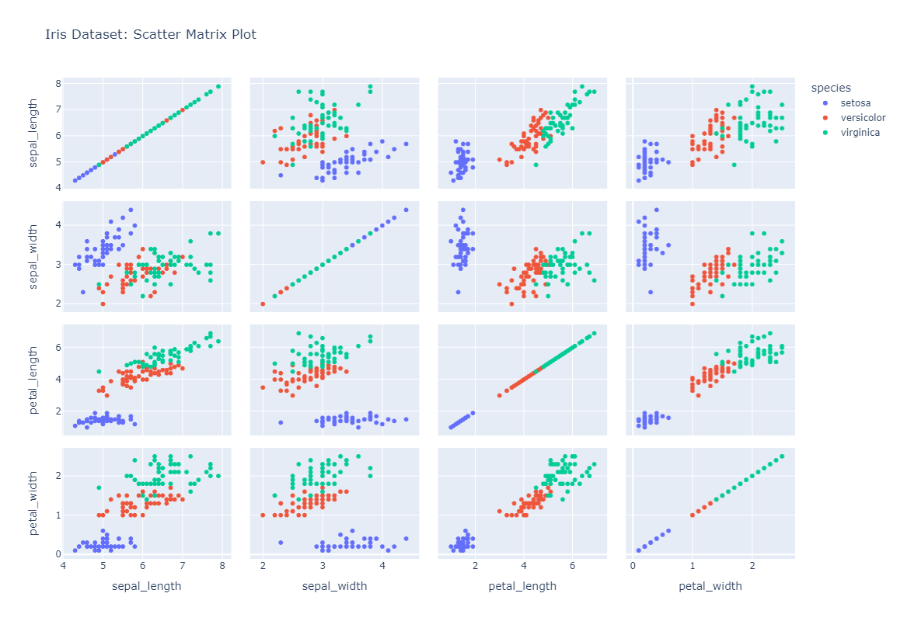

# Q5. What is Distplot? Using Plotly express, plot a distplot.

# Answer :

# A Distplot or distribution plot, depicts the variation in the data distribution. Seaborn Distplot represents the overall distribution of continuous data variables.

# Distplot is a seaborn library function that is used to visualize a univariate distribution of observations.

import plotly.express as px

tips = px.data.tips()

tips.head()

fig = px.histogram(tips , x = "total_bill" , y = "tip" , color = "sex" , title = "Tips Dataset : Showing Displot")

fig.show()

